Social Accountability in Egypt’s Social Fund for Development
- Social (Emergency) Fund in Context

Social Funds have their origins in the World Bank’s Structural Adjustment Programmes of the 1980s. The very first Social Fund was Bolivia’s emergency social fund (ESF) which was ‘established to cushion the adverse effects of economic crisis and subsequent stabilization program on the poor and to facilitate transition through the phases of structural adjustment (World Bank, 1987; 2003)’ on the 23rd June 1987. This fund was established as a temporary measure, which in fact ran until 1991.

In that same year, the Egyptian Social Fund for Development (SFD) was established by a Presidential decree 189 and with support of the United Nations Development Programme (UNDP). The fund was created to alleviate the hardship created by the returning Egyptian workers from the Gulf area as a result of the First Gulf War. For many it was seen as a social safety net, like in Bolivia, linked to the Government of Egypt’s Economic Reform and Structural Adjustment Programme. Fifteen years later, and the short-term emergency job creation remains the fund’s defining characteristic.

Today, the SFD is run by a semi-autonomous agency that reports to the office of the Prime Minister. It has a mandate to: (i) reduce poverty by supporting community-led initiatives; (ii) increase employment opportunities, and; (iii) encourage small enterprise development. According to the World Bank, an estimated 32% of Egyptians are potential beneficiaries of the fund (World Bank, 2009).

Despite the great potential scale and reach of the fund, Egypt is experiencing considerable demographic challenges. According to the World Bank, Egypt is experiencing an unprecedented “youth bulge” with approximately 60% of the population below the age of 30 (World Bank, 2010). In theory, such a large youth labour force is a blessing, but in practice generating adequate employment opportunities for this population has been a serious challenge, even for well-educated Egyptians. Indeed, as the IMF points out, unemployment is higher in the MENA region than any other in the world, and this is a largely youth phenomenon. Moreover, since 2011, unemployment in Egypt increased about 3.5 percentage points (IMF, 2012). In 2012, around one in four Egyptians between the ages of 18 and 29 were unemployed and just over half all young Egyptians are classified as living in poverty (BBC, 2012). The pressures of high rates of youth unemployment and poverty levels mixed with the shocks of high food and fuel prices culminated in a series of popular uprising which began on 25th January 2011 in Tahrir Square.

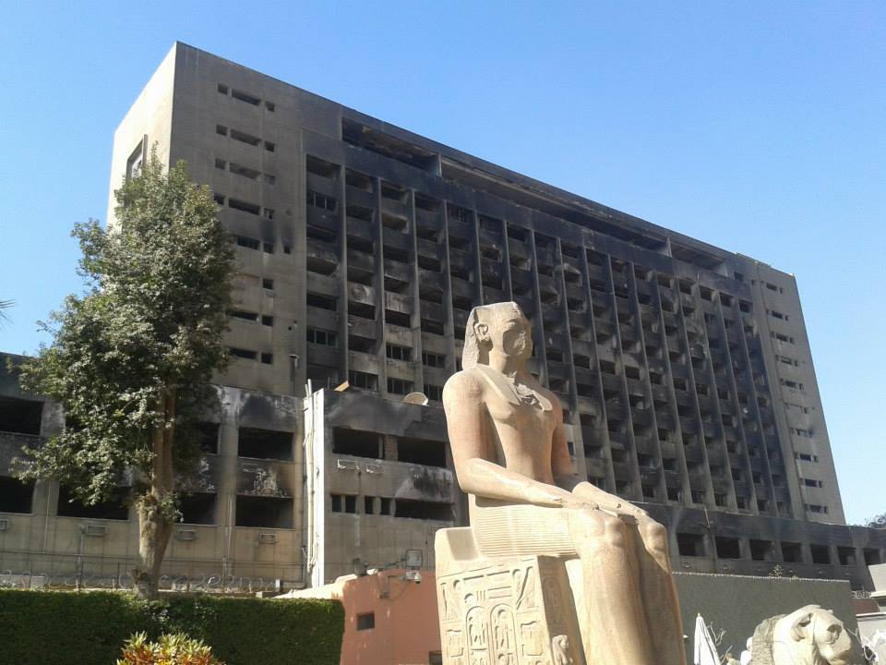
Burned National Democratic Party Headquarters, 2015
What is now known as the Egyptian Revolution included peaceful demonstrations such as the so-called “Friday of Accountability,” but also riots that burned police stations and the National Democratic Party Headquarters. Government resistance resulted in at least 846 deaths and 6,000 injuries during the 18 days of protests (BBC, 2011). As a result, President Hosni Mubarak was forced from power. The revolution has awakened new-found interest in democracy and government accountability from civil society, where citizens are more open to criticize government and to participate politically. There has been a proliferation of NGOs and unprecedented political participation in elections/referendums in addition to formation of several youth movements. Moreover, on the supply side, this process appears to have catalyzed greater interest from public agencies in strengthening the quality of services. A clear indicator of this shift can be found in the fact that the “Minister of Planning” was renamed the “Minister of Planning, Monitoring and Administrative Reform.” And he showed great interest in citizen monitoring of public services.

Notwithstanding, state-society relations have historically been confrontational, with limited space for negotiation. This is, in part, due to a hierarchical administrative system and legacies of military rule. And this helps to explain the limited scale of accountability work by NGOs in Egypt with the majority judicial processes and human rights violations (naming and shaming) rather than constructive engagement around service delivery outcomes.

- Social Fund Mechanics

The SFD targets the poorest areas of the country by using a poverty incidence map. SFD headquarters in Cairo implement activities through their 27 regional offices, and these help to identify local needs, mobilize community participation and monitoring the progress of projects. The SFD implements labour intensive investment projects in:

- Community development initiatives in health, education; and environmental sectors; employment
- Public works in water irrigation, road pavements; school maintenance; housing maintenance; youth centre maintenance; social solidarity units maintenance

These labour intensive projects typically have the duration of six months to two years in total and are primarily geared towards generating short-term employment opportunities for young Egyptians. Importantly, there are two main implementation modalities: community development projects are subcontracted to local NGOs and public works are carried out by government agencies.

Alongside this, the SFD local offices need to wrestle with the complexities of Egypt’s poorly decentralized administrative apparatus. The country does not have elected regional or local governments, but rather divided into 29 Governorates, led by presidentially appointed governors, often drawn from the Ministry of Interior or the military (Boex, 2011). As such, information flow and accountability relationships can vary significantly between governorates and often depend on the quality of relationships between the SFD office and local governor rather than formal bureaucratic procedures.

In this political-administrative context, the SFD has shown increased willingness for transparency and accountability, and as part of their aid effectiveness agenda the World Bank imposed a condition for this as part of the SFD contract. However, the fund was not entirely clear about what this would consist of, and they reached out to CARE Egypt for support to define what this would look like.

- Mainstreaming Social Accountability in the Emergency Labour Intensive Investment Project (SA-ELLIP)

In 2013, CARE International in Egypt received funding from the Foreign and Commonwealth Office and the Ford Foundation for the Mainstreaming Social Accountability in Emergency Labour Intensive Investment Project (SA-ELLIP). Given our past presence and experience, we chose to work in the governorates of Beni Suif, Assuit in Upper Egypt and Sharkeya in the Delta. These governorates cover the three main geographic distribution regions in Egypt: Delta; north of Upper Egypt; South of Upper Egypt.

According to the Baseline Assessment of Social Accountability in the Arab World, the ANSA network found that while social accountability is a new concept in the Arab world, it is not a new practice (ANSA, 2013). Social accountability can be defined as an “approach towards building accountability that relies on civic engagement, i.e., in which it is ordinary citizens and/or civil society organizations who participate directly or indirectly in exacting accountability (World Bank, 2004).” In particular, social accountability tends to consist of actions to facilitate transparency (to publish information), citizen monitoring of activities, citizen participation and engagement with public authorities and service providers to present information and demands in public forums, negotiate commitments and agree viable responses to improve the quality of service provision. For the purposes of the ELLIP project, drawing on the CARE’s Governance Programming Framework (GPF), CARE Egypt designed a social accountability model.

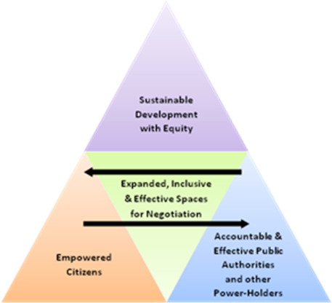

The model consists of the following components:

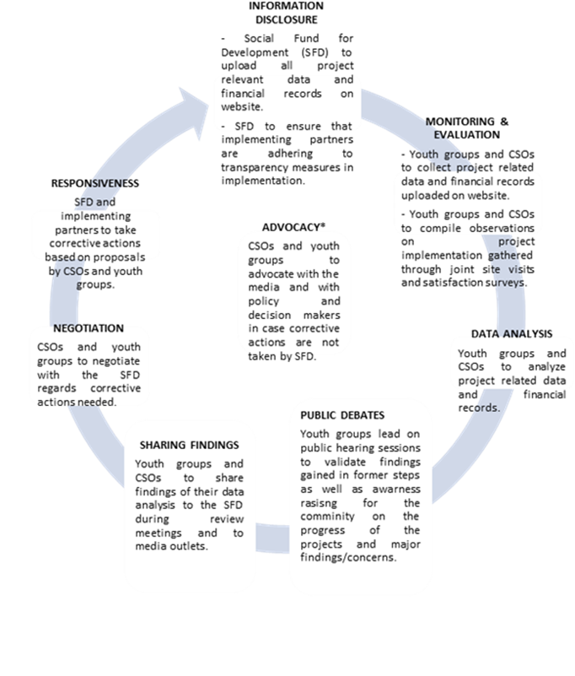
At the mid-point of the cycle, the team carried out a stocktaking exercise in which we evaluated the steps in the model. The following section breaks down the basic steps and learning from each of these at this mid-point.

Preparation
As with the implementation of any social accountability model, there was certain preparatory work that was necessary prior to implementation. However, this was not made explicit in the diagram above. On revision, the team identified that the model would have benefited from carrying out a preliminary stakeholder analysis in order to identify key actors, interests, incentives and information needs to secure buy in (1.1). The above social accountability model was developed based on a series of meetings with SFD headquarters staff, and this shaped the preparatory phase. However, this central focus and high dependence on information dissemination from the SFD perhaps made it difficult to carry out a systematic stakeholder analysis locally.

The team then felt, based on the stakeholder analysis, and with clearer direction from the SFD on what types of information we ought to track, that we could more clearly identify the geographic and sectorial scope for monitoring activities (1.2). This includes introductory meetings with local SFD staff and local implementing organizations.

As the model was driven by consultation with SFD headquarters, the tools and processes were tailored to suit the initial proposal. However in subsequent rounds and particularly if the model is introduced in new governorates, the team felt that it would be important to carry out a review of tools and processes (1.3) in order to better adapt them to the capacities, needs and existing accountability relationships and spaces within the local context.
Interests and incentives of the monitors

In Sharkeya, social accountability was a new concept. Monitors were incentivized by a sense that they could learn something new and to receive training and acquire new skills. They were also interested in improving the quality of services. As many of them were students, they also had free time to participate over the summer.

In Beni Suef, some youth had experience with social accountability, whilst others didn’t. For most, it was an opportunity for new experience, to acquire more skills, and get certificates. Some even felt they gained power; the opportunity to influence decisions locally. Inspired by the revolution, some even felt that this work could be a staging post for a future political career.

In Assuit, it was felt that advertising social accountability helped raise awareness and interest from CSOs, and this encouraged other people to participate. Monitors were interested in gaining new skills and felt they play an important role in their community and particularly wanted a role in monitoring grants.

Following a review of tools and processes, the next step is to introduce the social accountability model to key stakeholders (1.4). These include youth groups, media organizations, SFD staff and those of implementing CSOs.
Each monitoring group was presented slightly differently. In Assuit, they were presented as “enhancement groups” to monitor and help reach intended goals. In Beni Suef, they were presented as a group to “evaluate services and citizen satisfaction,” and in Sharkeya, they were presented as “helping get the best quality” – to turn 90% into 100%. There is no right or wrong way to present the initiative, but it is important to highlight that these differences in presentation reflect slightly different interests of local stakeholders.

Following the introduction of the model to key stakeholders, the field supervisors identified and commenced the training of facilitators (1.5). Alongside this, CARE carried out a baseline survey (1.6). Here, a key limitation is around citizen awareness and understanding of social accountability. Many respondents appeared to conflate transparency and accountability. Evidently, transparency is a necessary but insufficient condition for accountability, yet citizens’ responses were cautious. This may, in part, be due to the current political-judicial climate. The revolution has animated citizens, but the sentencing of 229 protestors to life imprisonment (Freedom House, 2015) demonstrates that there are still significant institutional barriers to citizen voice. On the other hand, each of the governorates highlighted that there is a general lack of awareness of social accountability concepts, tools and processes, and ultimately the different ways in which they can make demands and criticise government and service providers. In Assuit, this was the first experience of social accountability for the local population. This raised interest, but it also meant that the capacity building took longer. In Beni Suef, it was considered that willingness for citizen participation was weak, and in large part this was due to fear of reprisals from CSOs if they criticized them. Here, the reason is simple; there are tight patrimonial ties within kinship groups. Ultimately, criticising a CSO is akin to criticising one’s neighbour.

- Information Disclosure

To date, CARE’s intervention depends to a large degree upon what information is disclosed centrally. While SFD headquarters initiated the call for social accountability to be mainstreamed and appears committed, the roll-out of this commitment is complicated by the fact that there are parallel information systems due to two main types of stakeholder and their contract arrangements:

- Public works;
- Community development initiatives.

The key stakeholder in the former is state agencies. In the latter, initiatives are carried out through local CSOs. For public works, the SFD has its own data system which is housed centrally, but for the community development initiatives local SFD staff are responsible.

Originally, the proposal was to share information though the SFD’s central website. Moreover, a transparency clause was formally included in the contracts of local CSOs. However, information from local CSOs was generally not published on the website. Indeed, there was no complaints mechanism integrated in the website to flag this issue. Secondly, we found that, in practice, various CSOs had contracts which did not include this clause. This meant that the information received by the monitoring groups varied considerably between different projects and governorates. Local CSOs generally provide only a limited amount of information. The critique from headquarters is that they are unable to access all of this information, have no control and receive few updates. In practice, they receive quarterly reports. However, these reports focus on progress towards employment indicators rather than actual activities implemented in the projects themselves. In this way, it is obviously difficult for the SFD headquarters to track progress towards service delivery outcomes.

Local SFD staff makes financial and technical reports to the central unit based on this information, these are then reviewed and edited by central staff. Neither these edits nor the comments they have, nor indeed audit information are made public, however. There is thus policy incoherence between central and local SFD offices, and this seems largely attributable to high caseloads (# projects to manage per person) for local staff.

Caseloads for SFD Staff
Governorate | Assuit | Beni Suif | Sharkeya
SFD Staff | 5 | 4 | 2
Contracts | 85 | 40 | 28
Source: CARE workshop, 2015

In general, the team felt that 4 staff is perhaps enough to offer oversight on 10 projects. So, it is unsurprising that much is left to the discretion of local staff, and much is therefore left for CSOs themselves to determine.

Underlying this, of course, is the fact that it is not entirely clear what the expectations of each stakeholder group is in terms of what information they ought to receive. Therefore, the team proposed that we need to clarify with the SFD exactly what information we should expect to receive (2.1), so that we are tracking information that is useful to our key stakeholders, including the headquarters itself. This ought to be written directly in our terms of reference. On speaking with the headquarters, it appears that there is some guidance as to what information ought to be shared, yet we felt it would be useful to have a specific template, as this will help the monitoring groups to follow up more efficiently and effectively.

Once the most relevant information is clarified, each party ought then to release information for the monitoring groups (2.2). The monitors then track the release of this information against stipulated obligations (2.3). Here, it was noted that, at present, we are not clear exactly what information is used by each of our key stakeholder groups. So, an important step to include in the future would be to check what information key stakeholders are actually using (2.4). Prioritization has been a challenging task for the monitoring groups and this step should help to streamline the work in accordance with stakeholders’ stated, rather than merely perceived, interests.

- Input tracking

In order to track inputs from project related data and budgets, the team first had to design an input tracking and reporting format (3.1), effectively an extraction format in excel in order to elicit and order key information. This is something that evolved over time as different information came in. Youth were then trained on how to use the reporting format (3.2). The monitors then collected and compiled information into the reporting format, and periodically updated them (3.3). Monitors were then charged to write up observations on the data in their reports (3.4).

There were difficulties in assessing some report as many were incomplete, and typically the financial and technical reports did not properly match. In part, this seems due to the fact that reporting formats from CSOs are very flexible; much is left to personal judgement, and this makes the job of the monitors more challenging. Indeed, most service providers have their own indicators and track them independently, so aggregating information between different actors can also be a serious challenge for the monitors. Moreover, it appears that there were significant differences between different sectors. In Assuit, for example, there was a specific issue in the health sector, as monitors did not know or clearly understand various technical issues. In particular, they found it difficult to understand whether an itemized budget reflects the real costs of materials and equipment. So, CARE will need to have an increasing role in helping to decode this technical data and make it more accessible for the monitors and in order that it can be presented clearly in public hearings.

- Joint site visits

The social accountability model proposed to carry out field site visits in which relevant stakeholders from the monitoring groups, CARE, the SFD, the media, and others were able to corroborate or challenge the data published by CSOs and public works agencies. So, first the CARE team designed a tool for field visits – the field visit manual (3.5). The youth monitors were then trained on the use of this field visit manual (3.6) and field visits (3.7) commenced. The monitors then carried out field visit observation reports (3.8).

- Data analysis

Following the field visits, monitors were supported by field supervisors to analyze commonalities and discrepancies between input tracking and site visits – data validation (4.1) and to write a report with observations and recommendations (4.2). These observations were then shared with the SFD and local CSOs from whom data was gathered (4.3). The reports illustrate that there were many discrepancies between the input tracking reports and the field visits. For example, it was found in Sharkeya that the number of staff on the books and those that was actually employed differed. Another example which illustrates a wider problem is related to the lack of unitizing costs. Also in Sharkeya, we found that there was a block budget of 200,000 for planting trees, painting and numbering houses, but the number trees, amount of paint and how many houses to number were not specified, nor indeed were issues such as the colour or type of paint.

- Public hearings

The youth monitors were then trained on how to facilitate public hearing discussions (5.1). Again, in retrospect, the team felt it would be worth having a meeting to redefine the key stakeholders and key issues to be addressed (5.2), as these may change over the course of the initiative. For example, we found that the labour office could be a crucial stakeholder. The team did, however, have specific meetings with individual stakeholders (5.3). These were designed as pre-meetings before the forum, briefings for media partners and focus group discussions with other key actors. Invitations were then sent out to different stakeholder groups, including CSOs, the local SFD office, media, and direct and indirect project beneficiaries. The public hearing was then carried out (5.4). In Assuit, in the public hearing people were genuinely shocked about the difference between what is in the report for salaries and the real salaries. They felt if this is what a CSO is doing, they can only imagine what the government is doing. Following the public hearing a report was written with a summary of the findings (5.5.), a monitoring plan was developed (5.6) to track commitments, and a press release was prepared for journalists (5.7).

Here a crucial problem arose in how beneficiary status is defined and perceived. Beneficiaries are those who received employment opportunities, indirect beneficiaries are the wider community who benefit from service enhancement. Indirect beneficiaries refused to participate in the public hearing meeting in Assuit. The reason for this was that they did not perceive themselves to be beneficiaries at all. This speaks to a wider clientelist narrative which is replicated by the SFD, CSOs and even community members themselves that the fund is exclusively about employment, not service delivery. So, here it is clear that significant extra effort in the future will have to be made in raising citizens’ awareness and interest in service delivery outcomes.
Emergency jobs for day labourers

One fundamental issue that came out of the workshop was related to political discourse. In the baseline study, many beneficiaries complained about the short duration of projects (2 years), and in the site visits we commonly heard complaints about a lack of social security for workers. Here, it is necessary to make a distinction between CSO full time staff and day labourers. The former receive social security from the social security office, but day labourers receive no social security at all. Moreover, their employment was registered by day. So, for any given month, workers would be paid for a set number of days, but even in months with public holidays the same number is registered – which suggests significant corruption.

Underpinning this labour insecurity is the contract between the SFD and World Bank which stipulates that the SFD is not duty bound to provide social security. Undoubtedly, this is a measure to reduce costs, but it is also underscored by the fact that that job creation is presented as a stand-alone priority (“emergency employment projects”), and this filters down in the narrative of local staff. In Beni Suef, for example, it was mentioned that the focus is on “employment only.”

This also speaks to the wider issue of legitimacy of the monitoring groups. After the revolution it is argued that there is a more propitious climate for freedom of expression, and this can be a crucial driver to impel social accountability. It was commented that “people feel freer.” And this can help raise demand for accountability. However, it was noted that citizens feel more open to question government, but are very reticent in terms of criticizing CSOs, for the aforementioned reasons. Here it is also appropriate to consider who the monitors are. Although it was noted that the groups were composed of a variety of different youth representatives, many were university students. This is a great plus in terms of capacities for data processing and analysis, but it also involves a trade-off in terms of authentic representation, because better educated and better connected youth do not necessarily speak for the interests of the general population.

Three points bear further consideration here. Firstly, in some Upper Egypt governorates, tribalism has an important role to play in local power dynamics and in ensuring the legitimacy of civil society-led activities. So, here it may be important to consider how our work is linking to traditional forums and power structures. Secondly, Egypt has a system of directly elected Local Popular Councils (LPCs) at each subnational level. Although these councils have some advisory powers at Governorate, Markaz, and sub-Markaz levels, they may be important stakeholders to engage as part of CARE’s stakeholder analysis. Thirdly, as was discussed during the workshop, given the complexity of analyses that many of the monitors are carrying out around budgets, itemized costing, etc. at different junctures it may be worthwhile commissioning specific financial audits by agencies such as PwC, which have specific technical expertise that can be utilized to support the monitors, and would avoid turning the monitors themselves into accountants and auditors.

- Achievements

- More needs-responsive programming

In terms of achievements, the project has developed various tools, for example – input tracking guide and a site visits manual, which help the improvement groups to monitor the delivery of SFD projects. One example of success is that the CDAs sent an official request to the SFD asking to change one of the activities in their contract. The project was supposed to pave the streets of an area where the streets were already paved. At first the SFD regional office refused to change the agreement, however, this was discussed again in the public hearing session and the SFD have now promised to change the unnecessary activity to something else (e.g. painting the walls of the local school). Further, a CSO from a nearby village where CARE does not work heard about the social accountability activities by word-of-mouth and told CARE that they also have an agreement with the SFD which is to pave the sidewalks with tiles, but they don’t even have sidewalks in the village. These two examples demonstrate concretely how social accountability can help to make SFD projects more responsive to community needs and in so doing reduce waste for unnecessary activities and moreover shows there are also additional spill-over effects beyond the immediate reach of the project.

- Better reporting on service delivery

Moreover, the project already appears to be contributing to institutional effects within the SFD itself. In Assuit, for example, we find that the SFD did not monitor the outputs of projects. However, in the field visits the monitoring groups focused specifically on monitoring the outputs for communities. This was then reported back to the SFD office and the SFD requested to include an annex in their monthly report to include updates on outputs in the health sector. We have checked that they have done this. We believe that this is attributable to the project intervention because this is not happening in the other two governorates. It may be that we cannot take full credit for this, as there appears to be some impetus from the Ministry of Health to report on this data. However, in any case, this shows that the project is in some way contributing to inter-institutional coordination between the SFD and Ministry of Health. Equally, in a field visit in Beni Suef, the director of the SFD at governorate level asked if we can replicate the same experience in other districts. So, there is clear demand for this kind of work.

- Greater labour security

In the baseline, we found that direct beneficiaries are complaining that they do not receive social security from the CDAs. In the agreement between the SFD and World Bank, there is an article which states that the SFD will not cover any social security expenses. However, this omission is not included in the financial reports. The SFD is not following up on whether direct beneficiaries are actually receiving social security coverage.

Given the parallelism between the social security office and the labour office, full time employees are on a scheme of 40% contribution. Yet, for those employed part time the labour office asks only for a 6% contribution. Looking into the detail of this, we found that if CDAs were to register people through the labour office rather than the social security office it would be significantly cheaper. As a result of this, CDAs have now agreed to cover employees that were not covered through the labour office.

This is a direct liability for the SFD. So, we recommend that the SFD include this social security information as an annex to the financial reports. In this way, the SFD can start to audit when rights violations take place and enforce the rule of law. For future projects, we recommend that this be reflected in a formal agreement which binds the SFD and CDAs, even if it is not possible to include this information directly in financial reports. This speaks to a wider accountability issue for the World Bank and SFD who are indirectly breaking the law because of the nature of their contract which omits responsibility for social security payments but at the same time does not follow up on whether CDAs are, in fact, covering these benefits.

The labour office attended the public hearing in Assuit, so they have a specific legal duty to follow up on this. This incident proves how powerful information can be. Previously the CDAs complained about how the youth groups were criticizing them on issues that were not their responsibility. However, this shows that they are actually identifying matters of fundamental importance. We would also recommend, given limited HR capacity in the SFD centrally, that the CDAs be enabled to upload documents onto the SFD website themselves. Microsoft is a CARE partner and they can help us to make this an automated step, if this is something of interest to the SFD.

- How to improve the model

- Processes

- Information Templates: Given that the work depends heavily on what information is disclosed, we need to have greater clarity on which information should be disclosed by each actor and which information each actor needs. In the last meeting with SFD headquarters, we were offered some clarity on what these should be. So, we now need to carry out a similar consultation with other key stakeholders.

- Iterative Stakeholder Analysis: We have recognised that it is important to include a clearer and more systematic start-up phase. In particular, we need to carry out a clear stakeholder analysis in the start-up phase. This will help identify which information each actor should disclose and what information they should be aware of. For example, we found that holding just one awareness-raising session was not sufficient in some governorates. We feel it would be more effective to do a stakeholder analysis first before awareness sessions to then better target these sessions and focus information and training. In this process we can develop a more rigorous tracking system for the information that should be enclosed and then assess how beneficial this information release was to the public. We also feel that it will be important in the data analysis step to revisit the stakeholder analysis exercise to focus the information for the public hearings. When we first identified actors, we were not aware that the labour office was a key stakeholder, but carrying out this analysis now has allowed us to engage other key actors that can support the process.

- Building Legitimacy: Perhaps the major issue for the team to consider is the legitimacy of different actors both in terms of representation (in the case of monitoring groups) and community needs appraisal (in the case of local CSOs). CARE Egypt clearly plays a role in building interface between service providers and citizens, however, it appears especially given the non-participation of indirect beneficiaries in the Assuit public hearing, that more needs to be done in building bridges between other stakeholders which are not strongly engaged currently (see below).

- Actors

- We discovered that the SFD has a new governance unit. As the unit’s mandates and staffing is not entirely clear, it is premature to develop an engagement strategy. However, this will be a crucial stakeholder going forward, as ideally this unit can replace many of the roles and responsibilities that CARE has now.

- It is worth considering how we can engage more systematically with traditional authorities such as tribal chiefs and elected representatives such as Local Popular Councils (LPCs). This may play a crucial role in bolstering the legitimacy of both implementing CSOs and the monitoring groups.

- Finally, it may also be worth considering which discrete pieces of work might be outsourced to other service providers – these may include financial audits, which can be used to help strengthen the work of the monitoring groups, but as was mentioned in the workshop, may not be accessible enough to be presented in the public hearings.

At the time of this report, only one public hearing had been implemented.

