Learning brief

Towards learning centred planning, monitoring and evaluation (PME)

Lessons learned from CARE DK’s experimentation with Outcome Mapping in 6 countries in Africa and Asia

December 2015

Key Lessons

- The clarification of an actor focused theory of change through outcome mapping has triggered an important shift in focus of the programme’s M&E systems beyond the programme activities and particularly towards the changes in behaviour, practice, relationships or policy at the level of the boundary partners.

- Developing a ladder of change with progress markers can be helpful for developing and monitoring change trajectories around capacity areas that need to be strengthened. Such trajectories are more detailed and go beyond the “check box” nature of the classic capacity assessment. It is often not realistic to expect or support change across a large number of capacity areas. Hence some prioritization will be necessary.
- Having a clearly defined advocacy strategy is a precondition for developing meaningful progress makers that go beyond ‘policy change’ and also include other behavioural characteristics such as attitude change or change in discourse. An added value of the progress markers in advocacy work is that they allow to rack results that are easier to obtain over the lifetime of a project - e.g. changes in the relations between partners and a particular ministry
- Due to the nature of advocacy work, monitoring information needs to be captured and shared (among partners and within teams) quickly. This requires programme staff who are engaged in doing advocacy to get in the habit of drafting and sharing minutes and also writing down observed change in relation to different progress markers in the outcome journal. This remains a challenge across the country programmes.

- For the purpose of learning about progress across the various boundary partners as well as for upward reporting to the donor there is need to aggregate and synthesise the available monitoring information. For this purpose, it is helpful to categorize progress markers and assign a qualifying measure (e.g. low, medium, high) which can allow a trend analysis of the scope (e.g. 80% of groups showing change) as well as the level of change (e.g. 80% of groups have a high level of change). This provides a good basis for tracking change over time which helps to make the monitoring information useful for programme managers and for donors.
- A common observation across the cases is the importance of establishing the necessary rhythm and space for dialogue and discussion with relevant stakeholders about the progress markers. Regular monitoring or review meetings involving diverse actors within a programme’s theory of change provide such spaces for dialogue which also provide opportunities for data collection as well as analysis and collaborative learning.

- Enabling factors for outcome mapping include leadership and support from CARE DK and CARE programme teams, an environment of trust that allows dialogue and genuine participation, as well as the simplicity and the actor focus of the outcome mapping framework.

- Limiting factors include the sometimes limited planning, monitoring and evaluation (PME) capacity of the partner organisations, initial lack of ownership of outcome mapping based PME systems and its alignment with PME systems of the partner organisations, as well as the continued preference of government actors for numbers instead of qualitative monitoring information.

Contents
1. Introduction 4
2. CARE’s global Monitoring and Performance Management System 5
3. Dealing with complex change through outcome mapping? 6
4. Learning from outcome mapping in action? 8
5. Learning about results at the level of the boundary partners 12
6. Making sense of the monitoring information 17
7. Reporting against CARE DK global indicators. 19
8. Enabling and limiting factors for outcome mapping 19

Introduction

This learning brief, reports the lessons learned from CARE Danmark’s experimentation with outcome mapping as a learning centred planning, monitoring and evaluation approach.
Outcome mapping was introduced in 6 country programmes in order to better learn about development results at different levels within their intervention logic or theory of change. This was felt necessary because of CARE DK’s new strategic direction of supporting local civil society organisations. These organisations are responsible for their own strategic goals in relation to the mobilisation, service delivery as well as lobby and advocacy towards their respective target groups and local policy makers. CARE DK is now less involved in direct service delivery but instead focuses more on strengthening the capacity of local actors. It is believed that this approach will enable them to contribute towards local development even after the lifetime of the CARE DK programme.
The more traditional results based management approaches such as the logical framework or standard organisational capacity assessment tools were not felt to promote deeper learning about the more dynamic and unpredictable nature of capacity development processes. The same applied for learning about behaviour change at the level of local and national policy makers. Outcome mapping, through its strong focus on learning about changes in the behaviour or practices of local actors who are supported by development programmes, was felt to articulate well with CARE DK’s new strategic approach.
This learning brief takes stock of the progress and the lessons learned so far from the experimentation with outcome mapping in 6 country programmes (Nepal, Vietnam, Niger, Tanzania, Uganda and Ghana). A case report was worked out for each country programme, narrating the main experiences and results of the outcome mapping pilot. A cross case analysis was then carried out in order to identify common trends regarding the advantages and challenges of outcome mapping as well as recommendations for future PME practice. This policy brief presents the results of the cross case analysis.
The learning brief seeks to contribute towards sharing lessons learned as well as triggering further discussions about PME. This way it hopes to build up and take forward the ‘PME innovation’ momentum that is currently present in the various country programmes in a way that it can inform future PME policy and practice.

CARE’s global Monitoring and Performance Management System
The global theory of change with its three main ‘Domains of Change’ (see fig. 1) constitute the core of the CARE Denmark programming and monitoring system. In the figure below, the theory of change has been illustrated together with the key learning questions guiding the overall M&E and learning in CARE Danmark.

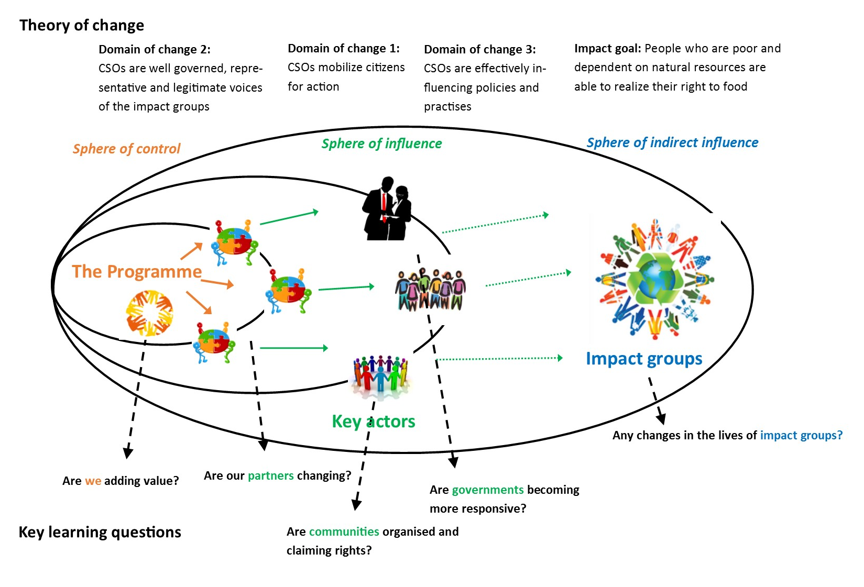
Figure 1: CARE DK’s global theory of change

- Civil society organisations mobilise citizen for action (Domain 1): The first domain relates to results and evidence of change related to CARE funded partner activities that seek to directly reach out to, and mobilize citizens as active rights holders while strengthening their ability to claim their rights.
- CSOs are well governed and function as representative, legitimate voices of the impact groups (domain 2): The second domain relates to the evidence of change at the level of the civil society partners, whom CARE is supporting with capacity development.
- CSOs are effectively influencing policies and practices in collaboration with peers (Domain 3): The third domain relates to the ability of civil society organisations to effectively influence policies and practices (including implementation of policies) in collaboration with peers and policy-makers.

The domains are understood as “areas of change” rather than phases that each programme goes through. The delivery of results in these domains is highly dependent on partners’ ability and interest in internalising new skills and knowledge, and putting them to wider strategic use. Hence, they are outside of the direct sphere of control of CARE, but in the sphere of influence.

CARE DK’s global theory of change recognises the fact that sustained change at the level of the impact groups relies for a large part on changes in the behaviour or practice of its local partner organisations as well as the key actors and local policy makers they influence. Hence, changes at these intermediary levels represent important results that CARE DK together with the country teams and their partners want to learn from through their planning, monitoring and evaluation systems. These changes also provide deeper insights in the extent to which local civil society is strengthened and the way in which this strengthening contributes towards positive change for the impact groups. Capacity development as well as lobby and advocacy have become key working areas for CARE DK more than direct service delivery.

Dealing with complex change through outcome mapping?
CARE DK and its partners have responded to the growing call for results based management by using a ‘theory of change’ based approach with global indicators in three domains: 1) mobilization of citizens by CSOs, 2) capacity strengthening of CSOs and 3) policy influencing by CSOs.

Such approach recognizes the importance of local civil society organisations taking ownership and responsibility of planning, monitoring and evaluation as well as decision making within the programmes supported by CARE. Hence, country programmes are now developed in function of the strategic plans of CARE’s partner organisations instead of the other way round. It also means that CARE can support civil society organisations in their respective development activities but it has no control over them. CARE even has less influence on the target groups of those civil society organisations such as citizens, community groups or policy makers. However, if changes do occur within these target groups or within the civil society organisations that CARE supports, then these changes will constitute important development results to which CARE may have contributed to.

However, working towards development results that constitute some kind of change (e.g. change in practice or behavior) within a social actor (e.g. organization, individual or group) is a complex affair. This means that the relation between cause and effect is rather unpredictable, and unexpected results often occur. Furthermore, dealing with societal issues often involves a variety of social actors who will have different understandings of and perspectives on the same issue.
Working towards complex social change: Within the CARE Niger PROGRES II programme it is up to CARE’s partners to develop their own initiatives based on their own strategic plans. A major objective of the programme is therefore the development of the local partner’s capacity so they can effectively give a voice to pastoralists at different levels so that they can address the structural causes of the marginalisation and poverty they are experiencing. Changes in practice and behavior of CARE’s partner organisations as well as changes in the behavior of their respective partners or target groups represent important results that can be monitored. (Care Niger case)

The standard result based management approaches such as the logical framework with SMART indicators did not provide enough useful information about the change processes that CARE DK was hoping to contribute to. Table 1 illustrates some of the PME challenges faced by various Country programmes. They often involve practical questions about how to reflect and learn from the effects of the programme’s support activities and to use this information to adjust strategy and to build an evidence base for lobby and advocacy. Also, the alignment of PME processes with partner’s capacities and priorities emerge as a common challenge.

Table 1: overview of PME challenges faced by various country programmes
Country programme | PME challenge (non-exchaustive)
Niger (PROGRES) | - Limited reflection on the effects of activities resulting in limited ability to adapt them according to lessons learned.  - No common understanding of the overall theory of change of the programme.  - No proactive documentation of experiences and evidence based information.  - Limited focus on gradual decrease of institutional support provided by programme team (working towards durability).
Nepal (Right to Food) | - There was a Theory of Change developed and some potential indicators but no M&E system.  - There were questions in the team about how to monitor capacity building of partners and to do more partner led M&E.
Vietnam (CASI) | - A need to better align pathways of change and capacity building support with partners’ and stakeholders’ own strategic plans, capabilities and internal priorities.  - Need for more detailed and accurate evidence-base that can be used by local and national planners and in advocacy
Uganda, Tanzania | - There was a log-frame and theory of change and a lot of output level targets but no clarity on how to measure qualitative changes including civil society strengthening and results of advocacy. Partner reporting was mainly focused on activities.
Mozambique | - There was a draft log-frame with overlapping levels and objectives which caused some confusion and a lack of clarity on the theory of change and how to measure changes in networks and results of advocacy and capacity building.

In order to address these challenges, CARE DK has invested in rolling out outcome mapping as a more complexity oriented approach in order to improve its PME practice. The expectation is that outcome mapping can help CARE DK to learn about change (e.g. capacity development) within the social actors that it supports or influences directly and indirectly as well as the effectiveness of its support strategies. Furthermore it was also hoped that outcome mapping would help to strengthen upward accountability to the donor and downward accountability towards the partner organisations it supports.
Why using outcome mapping?
- Outcome mapping helps a programme to focus on outcomes as changes in behavior and relationships of actors that are directly influenced by a development programme.
- Outcome Mapping provides practical concepts and tools (e.g. vision, outcome challenge, progress markers and strategy maps) that helps programme stakeholders to map and monitor the change pathway that they envision.

Learning from outcome mapping in action?
4.1. Developing a shared understanding of the programme’s vision.

At the start of the OM pilot, all country programmes involved, already had their overall objectives in place. Still, it was interesting to note that the vision exercise of outcome mapping was found useful by programme stakeholders (e.g. country team and partner organisations) to exchange together on their perspective of the ultimate change at impact level (level of the final beneficiaries) that they were hoping to contribute to through the programme. Hence, the exercise was felt to contribute to a better common understanding of the overall aim of the programme, the challenges it seeks to address and the impact it seeks to contribute to (see example of the Nepal case in the textbox below). In the Niger case, the vision exercise also contributed to a deeper analysis of the institutional context in which the programme has to operate.
Elaborating the vision in the Right to Food programme in Nepal: ‘’Although there was already an impact statement available for the RtF programme, this vision exercise proved to be important since the participants had not been part of the previous monitoring workshops and were therefore not fully aware of the vision or the hoped for impact of the programme. This exercise also helped to develop a common understanding of the overall aim of the programme. It also helped to develop a better common understanding of the overall challenges that the programme was aiming to address. (Nepal case report)

4.2. Clarifying the programme’s theory of change

From the various case reports, it emerged that outcome mapping has contributed towards a deeper and better shared understanding about a programme’s theory of change. In all the 6 cases, the simple ‘spheres of influence’ tool, provided a framework for discussion that helped the country teams and their partners to clarify which programme actors are within the programme’s sphere of control, its sphere of direct influence and its sphere of indirect influence. This proved to be a powerful stakeholder analysis tool that helped the programme teams and their partners to discuss and clarify which actors they are hoping to influence or support directly or indirectly in order to work towards their programme’s vision - see the example from the Right to Food programme in Nepal (fig. 2).

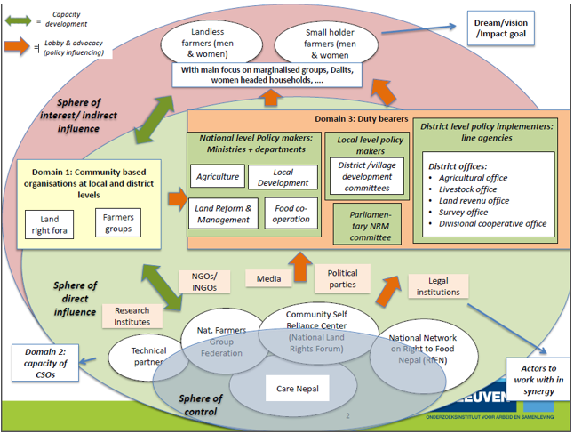
Figure 2: Actor focused theory of change of the Care Nepal ‘Right to Food’ programme

The visual in figure 2 helps to clarify that the CARE programme team, being situated in the programme’s sphere of control, may have a good level of control about programme finance, inputs and activities, but has no control about the practice and behaviour of the boundary partners. It can only claim to have some influence at that intermediate level. Hence, any change in practice or behaviour at the level of the intermediate actors can be seen as an important effect or result to which the programme may have contributed in its endeavour to work towards the vision.

Its added value lies in the fact that it specifies the social actors that are instrumental towards achieving the programme’s vision. It also visualises the fact that sustainable change at the level of the final beneficiaries (e.g. improved access to food by landless farmers) does not happen in an abstract way nor is it under the direct control or influence of an external development programme. Instead, it visualises the reality that sustained change at the level of the final beneficiaries (i.e. in the sphere of indirect influence) is dependent on changed practice, behaviour or policy at the level of intermediate actors (i.e. in the sphere of direct influence). In OM jargon, the intermediate actors situated in a programme’s sphere of direct influence are called the boundary partners.
The three domains of change from CARE’s global theory of change provided a useful framework to further categorise the boundary partners that were identified during the outcome mapping planning.

It is this visualisation of the actor focused pathway of change that has triggered an important shift in focus of the programme’s M&E systems beyond the programme activities and particularly towards the changes in behaviour, practice and policy at the level of the boundary partners. This shift in focus of the M&E system was evident in all the 6 cases and constitutes an important added value of the OM approach.

All country teams and partners felt that it was highly intuitive to talk about actors and influence instead of high level objectives (formulated at a high level and in a language catering to donor priorities). The stakeholder mapping also led to important reflections about the advocacy strategy and about who we need to influence to achieve the programme goals. It was found that the visioning and the stakeholder analysis were good planning tools in themselves and that they were essential in deepening the understanding that M&E cannot be separated from planning and that the whole programme team needs to be involved in doing M&E.
Focusing on the sphere of influence does not mean that a programme is no longer interested in the change at impact level: During one of the outcome mapping workshops with the CARE Nepal team there were critical questions about the main focus of the OM based monitoring system on change at the level of the boundary partners and less on change at the ultimate impact group. It was explained that OM acknowledges the reality that the programme will be able to analyse its influence at the level of the boundary partners and that change at that level is essential to contribute to sustainable change at the impact level. At the same time, this doesn’t mean that the programme would not be interested to learn about change at the impact level. While this might need additional M&E activities the OM system will also help in getting feedback about ‘impact’ since the impact groups are also the directly targeted actors in this project as members of farmers groups and village level land rights fora. (Care Nepal case report)

4.3. Monitoring changes in behaviour and policy through progress markers
Outcome mapping directs a programme’s monitoring focus towards the changes in behaviour, practice, relationships or policy of its boundary partners. When compared with the traditional results chain (inputs-outputs-outcomes-impact), these changes would correspond with the outcomes. However, in outcome mapping these changes (or outcomes) would be explicitly associated with a particular boundary partner. Hence, there will be less confusion about who is responsible for them. Also, a particular change will only be considered as a durable result if the change is owned by the boundary partner as can be observed by a change in their behaviour or practice and not merely an output of an activity of the programme.

What are outcome challenges and progress markers?
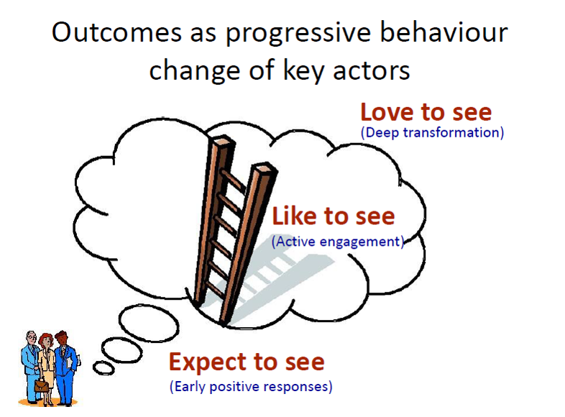
The outcome challenge and the progress markers are two concepts from outcome mapping that provide programmes with a framework to monitor change within its boundary partners.
- The outcome challenge is a mini-vision for a particular boundary partner. It describes the ideal changes in behaviour, practice, relationships or policy through which it would contribute maximally towards the overall programme’s vision. Instead of using the term “outcome challenge”, teams talk about the “dream” for each key actor. Often, the dream is the same or similar to the “love to see” changes.
- The progress markers describe the progressive changes (from initial changes to more profound changes) in the behaviour, practice, relationships or policy of the boundary partners. They are Measurable, Attainable and Realistic but they differ from SMART indicators by the fact that they are not necessarily timed nor do they require pre-specified targets. Knowing that the actual change is beyond the control of the programme and often unpredictable, the expected change as set out by the progress markers can turn out differently in reality. Therefore, the specific change will only become clear after it has happened. Hence, progress markers may also be adjusted during the monitoring cycles or new progress markers may emerge.

Using outcome challenges and progress markers: a tailor made approach
An interesting observation across the various cases is the fact that the development of outcome challenges and progress markers has followed diverse tailor made approaches that were considered best suited for the particular context of the country programmes.

Generally, the sets of progress markers developed during a first outcome mapping workshop were often adjusted in subsequent monitoring meetings with the programme teams and the partner organisations. This illustrates the strong iterative character of collaboratively developing a deeper understanding about the hoped for change process within the boundary partners.
  - In the PROGRES programme in NIGER, there was some concern about the quality of the initial set of the progress markers as well as the large number of them. They were adjusted and refined by the programme team and the partners before the elaboration of the data collection tools.
  - In the Tanzania Ardhi Yetu programme, the initial sets of progress markers for CBOs were categorized into 4 change categories to make data collection and analysis more manageable. The categories themselves reflect a progression from small changes “the groups are functioning” to bigger changes “group members are involved in planning” “groups collaborate with local government authorities to address land governance issues” “groups network and reach out beyond their own group”.
  - In the Mozambique PACT programme, the progress markers for all actors were categorized immediately after the first workshop to enable easier trend analysis based on the learning from Tanzania. In the Uganda FOREST programme, the team also realized that it is easier to do trend analysis if progress markers are categorized.

In all cases, an outcome journal format was chosen for capturing changes in relation to progress markers. The format generally include progress markers or progress marker categories, space to write down progress observed, a scoring of the significance of the change and a column for follow up actions to make change more likely in the future.

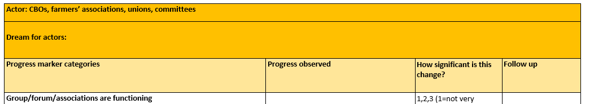

Learning about results at the level of the boundary partners
It is encouraging to see that the country programmes who integrated elements of outcome mapping in their monitoring systems have been able to track and report specific results at boundary partner level for the three domains of CARE’s global theory of change. Furthermore, there is evidence that country programme teams and their partners were able to draw lessons from the discussions and analysis of the monitoring information and use these as a basis for decisions or recommendations around future planning and corrective action.

5.1. Domain of change 2: Changes in partner’s capacity

Prior to the outcome mapping pilot, all countries used different partner capacity assessment formats to establish organisational baselines for partners and to inform discussions about capacity development priorities. With the outcome mapping pilot, ladders of change and progress markers were introduced as a method to develop a more detailed change trajectory for specific capacity areas.

- In the PROGRES programme in Niger, one of the partner organisations, AREN, developed progress markers for specific capacity areas that they wanted to strengthen in order to realise their overall vision of becoming a leading organization within the associative movement for the protection of the rights of pastoralists in Niger. The progress according to the progress markers is discussed during yearly review meetings with representatives of the partner organisations and CARE Niger. The results of the review meeting are documented in an outcome journal in Excel Format. An extract of the outcome journal is shown in figure 3 below.

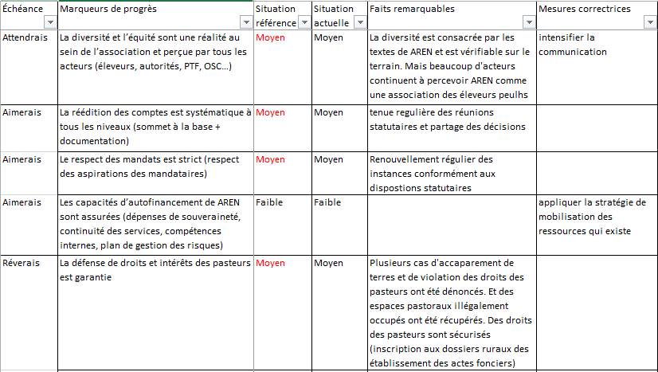

Figure 3: extract from the outcome journal of AREN (CARE Niger)

- In the Vietnam CASI programme, for monitoring internal capacity of the partner organisations, progress markers were categorised according to the domains of change of the existing partner profile tool (see figure 4). Within the 4 categories of change 1) external relationships with peers and policy makers, 2) Internal capacity issues (e.g. strategic management, HR, gender); 3) relationship with target groups, 4) capacity to engage in lobby and advocacy.

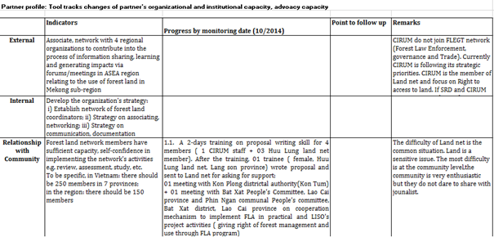
Figure 4: extract from CARE Vietnam partner profile tool

The emerging experience is that the ladder of change with progress markers can be helpful for developing change trajectories that are more detailed and go beyond the “check box” nature of the classic capacity assessment. For example, a typical capacity assessment indicator for “gender” is often “the organisation has a gender policy” or a gender focal person. A ladder of change can be used to challenge this and ask “then what?” If having a policy and a focal person is “expect to see” what would then be a sign of real transformation and change in the organisation “like to see” or “love to see”?

A recommendation is to prioritize capacity development areas and encourage partners to develop trajectories of change for priority capacity areas that need strengthening. This can then be used as a basis for tracking progress in capacity development over time. It is often not realistic to expect or support change across a large number of capacity areas (identified through e.g. a capacity assessment).

5.2. Domain of change 1: CSOs mobilize citizens

Across all the cases, the CARE partners have committed to support and monitor a large number of community based actors. In Nepal and Niger, partners are supporting and monitoring hundreds of farmers groups and in Uganda and Tanzania, partners are supporting hundreds of community based monitors. This creates challenges in terms of the time needed to track many actors and the analysis of large amount of progress marker information.

In cases when it is difficult to get field level staff or volunteers (e.g. community based monitors in Uganda, land rights monitors in Tanzania, front line land activists in Nepal) to fill in outcome journals, it has proven to be helpful to call regular meetings where the field level staff or volunteers share information about the groups they are supporting. This information can then be captured in a systematic way and the trend analysis can be done in the meeting (e.g. how many groups are now showing change in line with a progress marker or progress marker category).

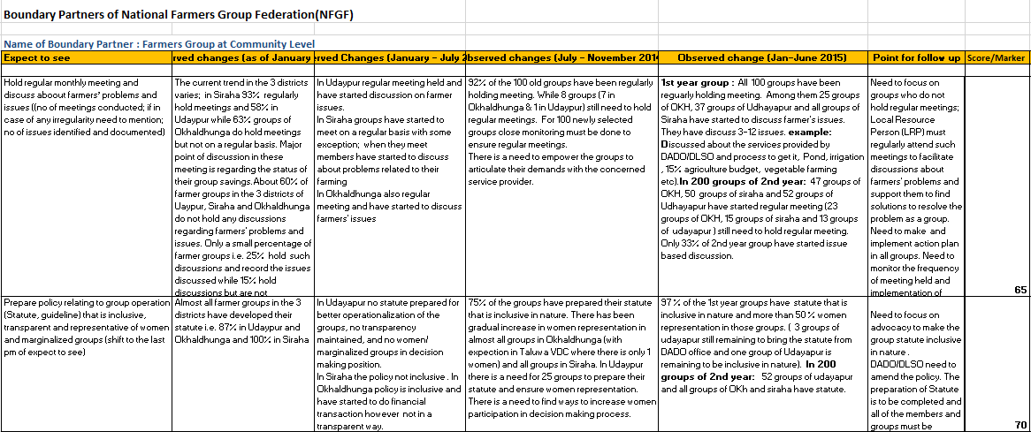
- In CARE Nepal’s Right to Food programme there is evidence of detailed information about changes at the level of community groups and local chapters of partners in their respective outcome journals which capture both qualitative as well as quantitative information. Figure 5 shows an extract from the outcome journal of the ‘farmer groups at the community level’. Monitoring information around the progress markers is mainly collected and discussed during monitoring meetings at various levels (local, district and national) during which the outcome journals of the respective boundary partners are updated and major achievements and follow up points and corresponding action plans are identified. This results in updated outcome journals for the various boundary partners on a 6 monthly basis. The information from these outcome journals is then further analysed by CARE Nepal’s Change analyst and capacity building specialist through aggregation and quantification of the monitoring information and by carrying out a trend analysis over time. This analysis is then used to produce a draft monitoring report which is further discussed during the yearly review and reflection meeting with the CARE Nepal programme team and the boundary partners. The outcomes of this review meeting then feed the yearly monitoring report that is compiled by the CARE Nepal programme team.
Fig. 5: extract from outcome journal for the national farmers group federation (NFGF)

In CARE Tanzania’s country programme, long lists of progress markers for CBOs were synthesised in progress marker categories which facilitated the monitoring process (see figure 6)

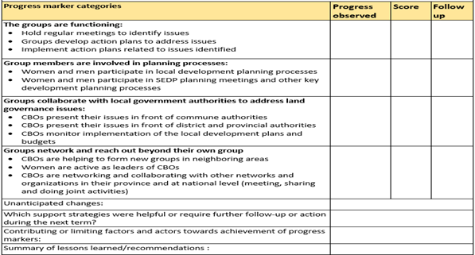
Fig. 6: Example of outcome journal with categories for CBOs

5.3. Domain of change 3: CSOs are effectively influencing policies and practices (outcomes of advocacy)

Across all the cases, CARE and partners have selected local and national level government stakeholders to be influenced and monitored. During the initial outcome mapping workshops, it was a challenge to come up with good progress markers for the government stakeholders. Where the advocacy strategy and targets were clearly defined, it was relatively easier, and where the advocacy strategy was more diffuse, it was a challenge for the teams to visualize what to “expect, like and love” to see from the government actors. It was also new to many to come up with progress markers beyond “policy change” and to include other behavioural characteristics such as attitude change or change in discourse. There was however, general recognition of the value of having progress markers which are easier to obtain over the lifetime of a project - e.g. changes in the relations between partners and a particular ministry - rather than only looking for an indicator e.g. a policy change - which might or might not be achieved within the set timeframe.

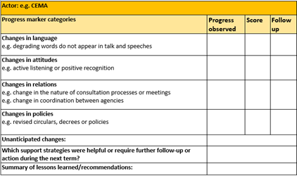
In the Vietnam case, progress markers were categorised according to open and broad change areas for advocacy (see figure 7).
Fig. 7: Outcome journal for advocacy relationship (Care Vietnam)

A recommendation would be that while this format can help inspire the team to look for changes beyond policy change, it would be helpful to make the categories a bit more specific to reflect the advocacy targets. E.g. instead of just “changes in attitudes” this could be “changes in attitudes towards ethnic minority representatives”. This ties the progress marker categories more closely to specific results of the programme.

In several cases, it was discussed that due to the nature of advocacy work, monitoring information needs to be captured and shared (among partners and within teams) quickly. E.g. if a minister commits to something in a meeting, partners need to share this information and quickly follow up. However, a challenge in several cases seems to be that this requires programme staff who are engaged in doing advocacy to get in the habit of drafting and sharing minutes and also noting down observed change in relation to different progress markers in the outcome journal.
Text box: A new M&E officer from a partner organisation questioned the feasibility of having national government stakeholders in the M&E plan because he could not see how he could collect all this progress markers information from people in ministers, etc. It was explained that this was also not the intention and that the colleagues who are doing the advocacy are the ones who should be monitoring the advocacy targets and documenting the changes observed. This is a key point in outcome mapping. The ones engaged in capacity development and advocacy should also be the ones in charge of monitoring the outcomes. M&E officers can support on the trend analysis but they are not supposed to collect all the information about the progress markers.

Making sense of the monitoring information
6.1. The rhythms and spaces for monitoring and reflection on progress
A common observation across the cases is the importance of establishing the necessary rhythm and space for dialogue and discussion with relevant stakeholders about the progress markers. Regular monitoring or review meetings involving diverse actors within a programme’s theory of change provide such spaces for dialogue. In the majority of cases they constituted both spaces for data collection as well as analysis and collaborative learning. This is illustrated by the CARE Niger case below:

Using monitoring meetings as spaces for data collection and analysis. When the compilation of the outcome journals by CARE Niger’s partners proved to be a challenge, the original M&E plan was quickly adjusted. Instead of giving the partners full responsibility for collecting monitoring data, review meetings were organised which provided a facilitated space for partner organisations and the CARE country team to discuss and analyse progress and compile the outcome journals together. This responded on the one hand to CARE Niger’s need to get more insight in the change that happens within the actors with whom it doesn’t work directly (i.e. the boundary partners of CARE Niger’s local partner organisations). On the other hand it also responded to the partner’s need to receive more support in the compilation of the outcome journals.

A common challenge across the cases is that it is hard to secure enough time to discuss and analyze this outcome information in the regular meetings, e.g. quarterly meetings. Often the agenda is fully taken up by review of activities and budgets. The discussion will also not happen by itself but needs to be facilitated (often by CARE). A recommendation is therefore to plan for the outcome discussion up front to secure enough time for this. It should after all be the most important question to answer in a review meeting: “are we seeing any change?”.

6.2. Synthesising monitoring information and visualizing trends
The monitoring of progress markers can result in large amounts of detailed qualitative information. Such information about a particular boundary partner can be useful for the front line staff who are working with that particular partner. But it can represent a challenge for learning as well as reporting about progress across the various boundary partners of the programme. It becomes even more challenging when boundary partners represent numerous groups based in various geographical areas as is the case with community based organisations such as farmer groups in Nepal or land rights monitors in Tanzania.

There is therefore need to also aggregate and synthesise the available monitoring information. For this purpose, it is helpful to categorize progress markers and assign a qualifying measure (e.g. low, medium, high) which can allow a trend analysis of the scope (e.g. 80% of groups showing change) as well as the level of change (e.g. 80% of groups have a high level of change). This provides a good basis for trend analysis which helps to make the monitoring information useful for programme managers and for donors. This is illustrated by the CARE Niger, Care Nepal and CARE Uganda cases below:

- In the CARE Niger PROGRES programme, progress markers are discussed in focus groups during monitoring meetings. The monitoring information is presented and verified and scores are verified in relation to the attainment of the progress markers (Low, Medium or High). The partner organisations together with representatives of the boundary partners fill in the outcome journals. Information from each monitoring cycle is synthesized in a brief document with main findings about progress, contributing factors, points of attention and recommendations for the future. For the purpose of clarity of reporting, no distinction is made between expect-like-love to see progress markers in the synthesis report. Progress over time for each boundary partner is visualised as a percentage of the progress markers that scored Low, Medium or High (see figure xxx below). The synthesis report also includes a summary of the observed changes according to the progress markers as well as specific recommendations based on the lessons learned during the monitoring process (see figure 8).
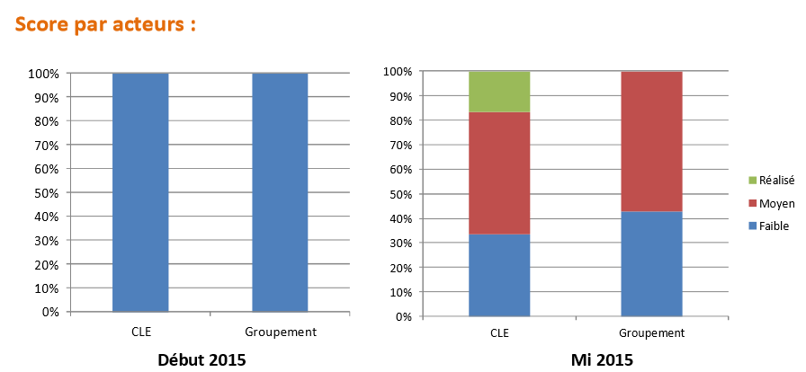
Figure 8: Progress over time for the boundary partners: local water committees (CLE) and local groupings

- In the Uganda FOREST programme, the CARE team started organizing the progress markers for government stakeholders into change categories. The process involved listing all the progress markers and then grouping them into categories that could serve as a broad heading for the type of change envisioned. The categories are: government collaboration with CSOs (measured through progress markers about whether the government consults CSOs, participates in research, etc.), accountability in terms of better enforcement of laws and response to corruption (measured through a range of specific progress markers), government developing specific forest policies, laws and guidelines (measured through specific progress markers related to advocacy targets - e.g. guidelines for a tree fund). (see figure 9)

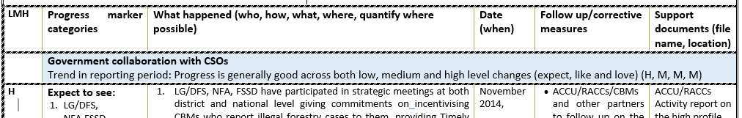
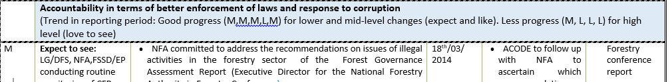
Fig. 9: example of categorization of progress markers in the outcome journal for policy makers.

The next step is to give a rating per category (low, medium, high change) and then compare ratings over time from monitoring cycle to monitoring cycle. These figures can then be plotted into a graph to show the trend over time which may help to visualize whether the change is positive and progressive, if it is stalled or reversing.

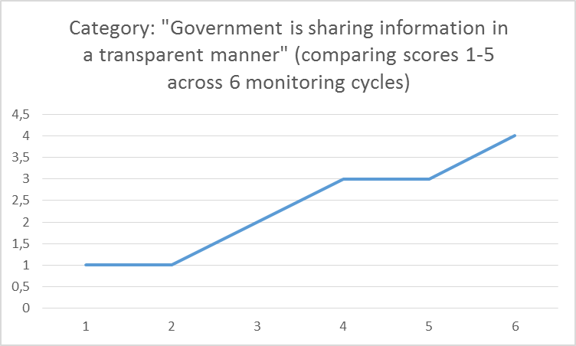
Example graph showing the trend in scores over monitoring cycles

Reporting against CARE DK global indicators
In line with its global theory of change CARE DK formulated global indicators for each of its three domains of change in order to allow aggregated reporting cross the various country programmes. These global indicators allow for ratings and comparisons across domains and programmes and makes it easier to report on a ‘global’ CARE Denmark programme.

The results of the first outcome mapping based monitoring cycles learned that besides providing useful information to report against the global indicators, they also allowed for a more nuanced insight in the change process at the level of the boundary partners. This illustrates that the global indicators can guide upward accountability but they should not be considered as the objectives of the programme. While all the detailed monitoring information about the progress markers may not need to be reported upwards to CARE DK, it serves an important function at the operational programme level where it allows learning about the effectiveness of the programme strategies to influence or support the boundary partners.

Enabling and limiting factors for outcome mapping
From the cases the following enabling and limiting factors emerge that played a role in the practical implementation of the OM based PME systems.
Enabling factors:
- Leadership and support from CARE DK and the CARE programme teams emerge from the cases as strong enabling factors. Such support has proven essential given the practical implications that come with the values of an OM based M&E system such as active participation, local ownership and collaborative learning. Organising the necessary space for dialogue and collaborative review around the progress of the programme requires a considerable investment of financial resources and time. It also requires a specialised tailored coaching support from the CARE towards its local partner organisations and sometimes also their respective boundary partners. Examples of this support include finance for organising review meetings, bringing in M&E consultants, refresher trainings, secondary analysis of monitoring data and compilation of monitoring reports, development of learning briefs based on lessons learned across the country programmes who are piloting OM.
- An environment of trust that allows dialogue and the presence of a group of people with a strong desire to learn from practice in order to improve it is another enabling factor. That such an environment may take time to develop can be expected. Focusing on the more qualitative aspects of changed behaviour and practice was rather new for a majority of the country programmes that were more used towards monitoring activity outputs.
- The simplicity and the actor focus of the outcome mapping framework made it easy for the various programme stakeholders to relate with. Instead of dealing with abstract PME jargon such as inputs, outputs, outcomes and impact and SMART indicators, the OM framework made stakeholders talk about the actors that they hope to influence with their day to day activities and the change they hope to contribute to through this influence. This close link with the day to day work made it easier to avoid a situation where the PME activities are seen as the sole responsibility of the PME staff.

Limiting factors:
- Limited PME capacity particularly in relation to the monitoring changes in practice and behaviour of the boundary partners that one seeks to influence can be a limiting factor. Practical challenges have emerged across the cases around regular recording of observed change within the outcome journals, analysis of the monitoring data, using evaluative rubrics to assign a quantitative score towards the level of realisation of progress markers (i.e. establishing specific criteria for Low, Medium and High), keeping track of geographical reach of the observed change across multiple units of the same boundary partner type, etc.
- Also the initial lack of ownership of the OM based PME system has been exacerbated in a number of cases through the high turnover of PME staff. Ongoing coaching support from CARE towards its partner organisations therefore remains important.
- Alignment of the OM based PME approach with existing PME systems of the partner organisations has proven to be a challenge in a number of country programmes. It is not uncommon that partners with considerable PME experience may opt for other PME approaches (e.g. one of CARE Niger’s partner organisations who preferred to use the Farmer Advocacy Consultation Tools’ instead of the OM based approach). In such cases it will be important to explore if the various information needs from different programme stakeholders, including CARE, are satisfied. If not, then some adjustment of existing PME tools could be considered as was the case with the partner and audience profile tools in the CARE Vietnam case.
- Information needs of government actors have in certain cases not been in line with the monitoring information that emerges from an OM based PME system. The CARE Nepal team for example has found it challenging ‘’to convince government stakeholders regarding OM tools, methodology and practice because they seem more interested in the numbers rather than the qualitative information’’ (Care Nepal case report).

